Team:

Will Brown

Sierra Dreisbach

Ernest Pambuku

**Morning Ritual**

Morning Ritual is a single-player minigame compilation game. The player has a ritual every morning and if they don’t follow it, they will slowly begin to lose it. Set the baseline for your morning routine and try to get as close to your routine as possible every morning. Try to maintain your ritual for a week. You have to wake up, take a shower, brush your teeth, eat breakfast, then get dressed. Remember, you want to remember what you did and how you did your tasks each day. If you don’t, your sanity will take a hit and you’ll realize this morning ritual has a purpose.

It was created using Unity 2018.3.1f.

**Mechanics:**

**Gameplay Loop:**

The game will be played throughout 7 days. You will play a set of minigames each day and the difficulty of the minigames increases each day. The first day is a baseline for how you’ll treat the rest of your days. You will set the time to wake up, how hot your water is, how many times you brush your teeth, what cereal you eat, how much milk you pour, and what shirt you wear. Each day you will try to replicate your first day values and the difficulty to accomplish your tasks will increase. An example would be the clock moving faster and faster each day so you have a harder time to stop it at your first day time.

**Win State:**

If you manage to survive the 7 days without your Chaos Meter reaching 0, then you will win the game.

**Loss State:**

If the Chaos Meter reaches 0, you will lose the game.

**Chaos Meter:**

The Chaos Meter is a value that will affect how you perceive the world. You will start at 100 and every time you fail a task or miss a time, the chaos meter will take a hit depending on how severely you messed up. An example would be you choosing a different cereal than the cereal you chose the first day. After the Chaos Meter goes past a certain value, you will start to see the visuals of the game differently as well. You might notice the milk is blood red now or your teeth are all red. This is your warning that your meter is getting too low. Accomplishing your tasks correctly will fill your Chaos Meter back up so you can continue playing and return your vision back to normal.

**Breakfast:**

A minigame where you will first choose to pour milk or choose your cereal. If you pick the milk option first you will automatically lose because what kind of monster pours milk first. For the cereal minigame, there will be random cereal boxes with random cereal designs. You will choose your favorite on the first day, then each day your cereal will be there but so will other cereal boxes. Remember what you chose.

After you pick your cereal you will go to the milk minigame where you have to pour milk until you are satisfied. Remember how high you poured your milk on the first day because each day the pouring speed will increase and it will be harder to match your first day.



*Breakfast*

**Brush Teeth:**

The brush teeth minigame will having you using the A and D keys to go back and forth to brush your teeth. You will set the amount of times you brushed on the first day and then try and replicate it each day. There is a toothpaste meter that will end the minigame so try and hit your values before you run out of toothpaste.



*Brush Teeth*

**Get Dressed:**

In the Getting Dressed mini game you will pick a shirt of one of the primary or secondary colors. Each day more shades of each color will be added and you will try and pick the same color you picked the first day.

Didn’t have time to work on this game week 1 so there is not gif

**Shower:**

In the Shower mini game you will set the temperature of the water by rotating a knob by spinning your mouse. Each day you will try and get this same temperature even without using a thermometer.



**Wake Up:**

In the Wake Up mini game you will stop the clock with the space bar when you want to wake up. Each day you will try and stop the clock at the same time, but the clock will be moving faster and faster.



**Influences:**

**Wario Ware Games:**

The frantic fast-paced minigames of Wario Ware were an influence to how we came up with ideas for the minigames in our game. The gradual difficulty and speed increase was something we wanted to use from these games.

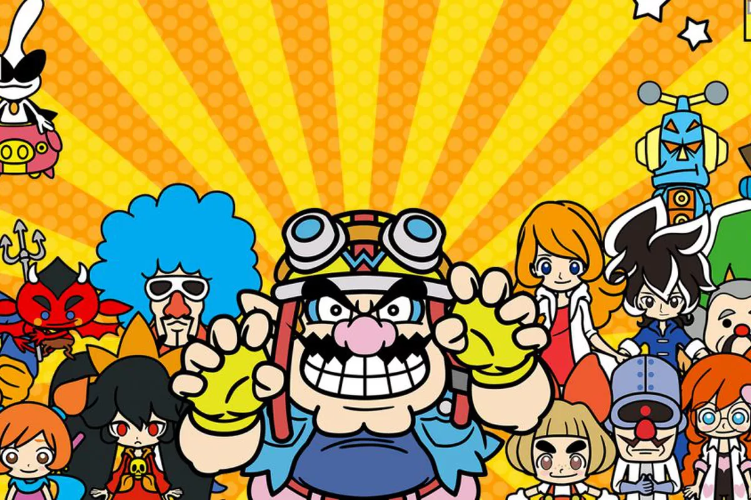

*Wario Ware Gold*

# 

# 

# 

# Assets:

All our assets will be pixel art made in Photoshop. Here is what we have created so far:

Brushing Teeth:

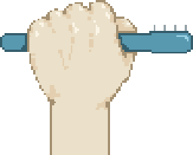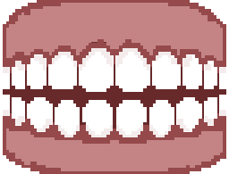

Pouring Cereal:

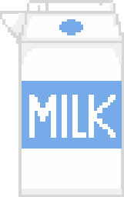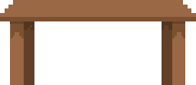

Showering:

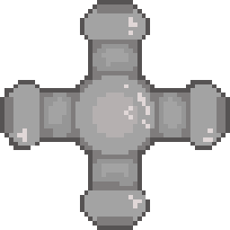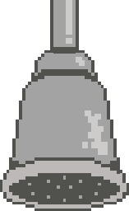

Waking Up:

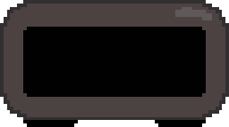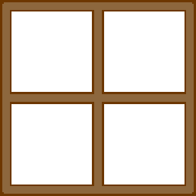

Getting Dressed:

